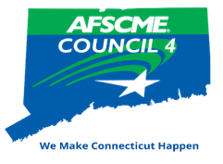

Biennial Recognition Dinner

Friday, April 25, 2025

Mystic Marriott Hotel



Call for Nominations

|  |  |
| --- | --- |
| **Your Name:** | **Local Number:** |
| **Your email address:** | |

|  |  |
| --- | --- |
| **Nominee:** | **Local Number:** |
|  | |
| Briefly explain why this member should be honored. Please provide specific details concerning your nominee as Council 4 Recognition Awards are presented to a maximum of two recipients per local/chapter. Please use the back of the form if additional space is needed. | |
|  | |
|  | |
|  | |
|  | |
|  | |
|  | |
|  | |
|  | |
|  | |
|  | |
|  | |

Please Note: Eligibility for Member Awards is limited to one award within the last four years.

Submit Your Nomination to:

AFSCME Council 4 AWARDS, 444 East Main Street, New Britain, CT 06051

email: mcbatchelder@council4.org

**NOMINATIONS MUST BE RECEIVED BY MARCH 24, 2025**

Council 4 is on the lookout for members who are dedicated unionists and labor activists always going the extra mile for their Union siblings, or are outstanding citizens making a difference in their community or in someone’s life.

If you have these people in your ranks, please consider submitting their names to the Recognition & Awards Committee.